Builder Design Pattern - Complete Notes

Introduction
The Builder Design Pattern is one of the most commonly used design patterns in real-world applications. When it comes to object creation, the industry prefers the Builder pattern over using the new keyword directly. This pattern is particularly useful for creating complex objects with many parameters.
Yes, we do have singleton pattern where we can get object without using new keyword but there we can only get single object not multiple, but we want multiple object as well.

The Problem: Why Do We Need Builder Pattern?

Example: HTTP Request Object
When we send request from one service to another we send a HTTP request
Http request
S2
S1

Consider building an HTTP Request class with the following fields:
- URL (String)
- Method (String) - GET, POST, PUT, DELETE, PATCH
- Headers (Map<String, String>) - Content-Type, etc.
- Query Parameters (Map<String, String>)
- Body (String/JSON)
- Timeout (int) - Default 60 seconds

Problems Without Builder Pattern

Problem 1: Constructor Overloading (Telescoping Constructor)
When creating objects with multiple parameters, we need multiple constructors:
text
// Constructor with only URL
public HTTPRequest(String url)

// Constructor with URL and Method
public HTTPRequest(String url, String method)

// Constructor with URL, Method, and Headers
public HTTPRequest(String url, String method, Map<String, String> headers)

// ... and so on for every combination
Issues:
- Need to create many constructor combinations
- Difficult to maintain as new fields are added
- Error-prone when passing parameters (order matters)
- Violates Open/Closed Principle

Problem 2: Mutability Issue
If we use setters instead of constructors:
text
request.setUrl("...");
request.setMethod("...");
request.setBody("...");
Issues:
- Object becomes mutable (can be changed after creation)
- Some objects should be immutable for critical applications
- Thread safety concerns
- Validation becomes difficult
Solution – remove setters from the class but we generally don’t remove setters from the class

Problem 3: Inconsistent State
When using setters:
text
HTTPRequest request = new HTTPRequest(url, method);
request.setBody(body);
// Forgot to set timeout!
request.execute(); // Runtime error! b\c for execution all fields are required
Issues:
- Object may be in inconsistent state during construction
- No compile-time guarantee that all required fields are set
- Runtime errors instead of compile-time errors
- Runtime errors are the worst kind of errors

Problem 4: Scattered Validation
Validation logic needs to be implemented everywhere, wherever we are using the execute() method:
text
if (request.getUrl() != null &&
request.getMethod() != null &&
request.getBody() != null) {
request.execute();
}
Issues:
- Validation code is scattered across the codebase
- Duplicate validation logic
- Hard to maintain consistency

Code for “WithoutBuilder” --- see Notes

Solution: Builder Design Pattern

Core Concept
The Builder pattern separates the construction of a complex object from its representation. Instead of the client directly creating the object, a Builder class handles the object creation.

Key Components
- Target/Product: The complex object being built (e.g., HTTPRequest)
- Builder: Class responsible for creating the Target object
- Director (optional): Class that manages builders for common configurations
- Client: The code that uses the Builder to create objects
Builder
Target
Client

Builder class will solve all the above problems discussed.

Classic Builder Pattern Implementation

Step 1: Make Target Constructor Private
java
public class HTTPRequest {
private String url;
private String method;
private Map<String, String> headers;
private Map<String, String> queryParams;
private String body;
private int timeout;

// Private constructor - forces use of Builder
private HTTPRequest(String url, String method,
Map<String, String> headers,
Map<String, String> queryParams,
String body, int timeout) {
this.url = url;
this.method = method;
this.headers = headers;
this.queryParams = queryParams;
this.body = body;
this.timeout = timeout;
}

// Friend class declaration (C++) or package-private access (Java)
// This allows Builder to access private members

public void execute() {
System.out.println("Executing " + method + " request");
// Actual HTTP call logic
}
}

Step 2: Create Builder Class
java
public class HTTPRequestBuilder {
private HTTPRequest request;

public HTTPRequestBuilder() {
this.request = new HTTPRequest();
}

// Intermediate Methods - return Builder for chaining
public HTTPRequestBuilder withUrl(String url) {
this.request.url = url;
return this;
}

public HTTPRequestBuilder withMethod(String method) {
this.request.method = method;
return this;
}

public HTTPRequestBuilder withHeader(String key, String value) {
if (this.request.headers == null) {
this.request.headers = new HashMap<>();
}
this.request.headers.put(key, value);
return this;
}

public HTTPRequestBuilder withQueryParam(String key, String value) {
if (this.request.queryParams == null) {
this.request.queryParams = new HashMap<>();
}
this.request.queryParams.put(key, value);
return this;
}

public HTTPRequestBuilder withBody(String body) {
this.request.body = body;
return this;
}

public HTTPRequestBuilder withTimeout(int timeout) {
this.request.timeout = timeout;
return this;
}

// Terminal/Terminating Method - returns final object
public HTTPRequest build() {
// Validation
if (request.url == null || request.url.isEmpty()) {
throw new RuntimeException("URL cannot be empty");
}
if (request.method == null || request.method.isEmpty()) {
throw new RuntimeException("Method cannot be empty");
}
if (request.timeout <= 0) {
request.timeout = 60; // Default timeout
}
return request;
}
}

Step 3: Client Usage
java
public class Main {
public static void main(String[] args) {
HTTPRequest request = new HTTPRequestBuilder()
.withUrl("https://api.example.com/users")
.withMethod("POST")
.withHeader("Content-Type", "application/json")
.withHeader("Authorization", "Bearer token123")
.withQueryParam("page", "1")
.withBody("{\"name\": \"John\"}")
.withTimeout(30)
.build();

request.execute();
}
}
Code of “BuilderPattern” – see Notes
- Now you can’t mutate the values as there is no setter in “HTTPRequest” class and all members are private. If you want to change any object you again have to create new builder and call .build()
- No overriding of constructors are there.
- We have a common validation in build() method – no scattering of validation
- If you forget to set anything then it will be caught in common validation
Therefore, all problems are solved.

Key Concepts

Method Chaining
Each intermediate method returns this (the Builder instance), allowing multiple method calls to be chained together in a single statement.

Intermediate Methods vs Terminating Methods
- Intermediate Methods: Methods like withUrl(), withMethod(), etc. that return the Builder for continued chaining
- Terminating Method: The build() method that returns the final Target object and ends the chain

Immutability
Once the build() method is called, the resulting object is immutable:
- No setters exist
- Fields are private
- To modify, create a new Builder and build a new object

Centralized Validation
All validation logic is centralized in the build() method:
- No scattered validation code
- Compile-time safety (must call build())
- Runtime exceptions for invalid states
Simple UML Diagram:-
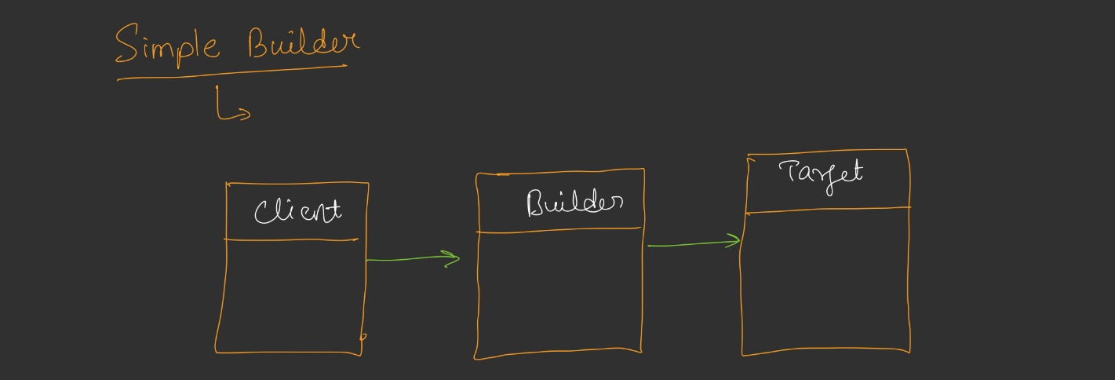

Builder with Director Pattern

Purpose
The Director pattern encapsulates common/reusable build configurations. It provides pre-configured build templates for frequently used object configurations.

Implementation
java
public class HTTPRequestDirector {

// Static methods for common configurations
public static HTTPRequest createGetRequest(String url) {
return new HTTPRequestBuilder()
.withUrl(url)
.withMethod("GET")
.build();
}

public static HTTPRequest createJsonPostRequest(String url, String jsonBody) {
return new HTTPRequestBuilder()
.withUrl(url)
.withMethod("POST")
.withHeader("Content-Type", "application/json")
.withHeader("Accept", "application/json")
.withBody(jsonBody)
.build();
}

public static HTTPRequest createAuthenticatedGetRequest(
String url, String authToken) {
return new HTTPRequestBuilder()
.withUrl(url)
.withMethod("GET")
.withHeader("Authorization", "Bearer " + authToken)
.build();
}
}

Client Usage with Director
java
// Instead of building from scratch every time:
HTTPRequest getRequest = HTTPRequestDirector.createGetRequest(
"https://api.example.com/users"
);

HTTPRequest postRequest = HTTPRequestDirector.createJsonPostRequest(
"https://api.example.com/users",
"{\"name\": \"John\"}"
);

Benefits
- Reusable build configurations
- Reduces code duplication
- Easy to maintain common patterns
- Client code becomes cleaner
Code of “HttpRequestDirector” – see Notes

UML Diagram:-
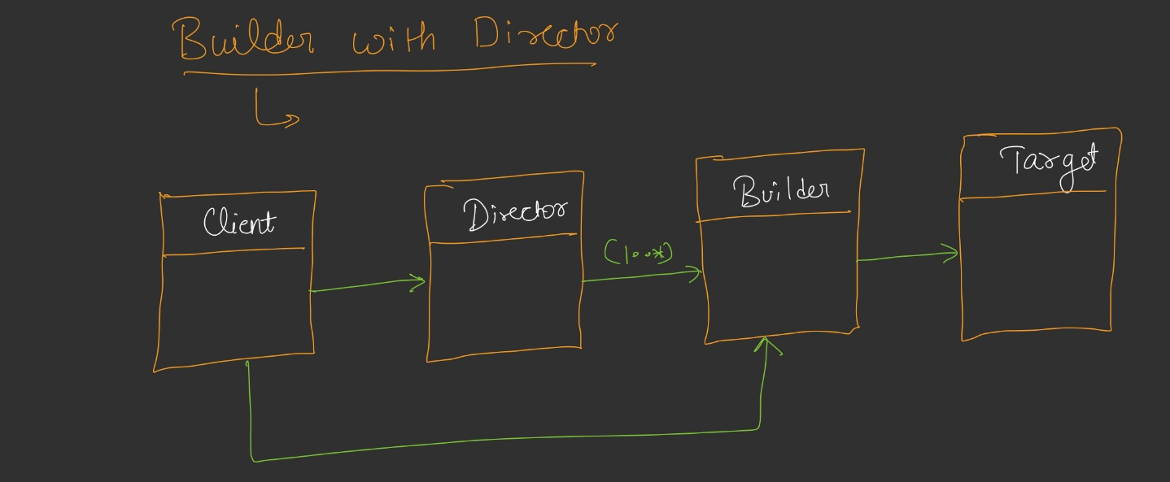

Step Builder Pattern

Purpose
The Step Builder pattern enforces a specific order of building steps. It ensures that certain fields are set before others, providing compile-time guarantees that all required fields are provided in the correct sequence.

Problem It Solves
In the classic Builder pattern:
- Client can call methods in any order
- Client can skip required fields
- No compile-time enforcement of build sequence
The Step Builder solves this by:
- Enforcing step-by-step object creation
- Using interfaces/abstract classes for each step
- Only exposing the next valid step to the client

Real-World Analogy
Pizza Ordering: When ordering pizza, you must specify:
- First: Crust type
- Then: Sauce type
- Then: Toppings
- Finally: Confirm order
You cannot specify toppings before choosing crust - the system enforces the order.
House Construction:
- First: Foundation
- Then: Walls
- Then: Roof
- Then: Doors/Windows

Implementation Concept

Step 1: Define Step Interfaces
java
// Step 1: URL is required first
public interface UrlStep {
MethodStep withUrl(String url);
}

// Step 2: Method is required second
public interface MethodStep {
HeaderStep withMethod(String method);
}

// Step 3: Headers are required third
public interface HeaderStep {
OptionalStep withHeader(String key, String value);
}

// Optional Step: Optional fields can be set in any order
public interface OptionalStep {
OptionalStep withBody(String body);
OptionalStep withTimeout(int timeout);
OptionalStep withQueryParam(String key, String value);
HTTPRequest build();
}

Step 2: Implement Step Builder
java
public class HTTPRequestStepBuilder implements UrlStep, MethodStep,
HeaderStep, OptionalStep {
private HTTPRequest request;

private HTTPRequestStepBuilder() {
this.request = new HTTPRequest();
}

// Entry point - always start with URL
public static UrlStep getBuilder() {
return new HTTPRequestStepBuilder();
}

// Step 1: URL
@Override
public MethodStep withUrl(String url) {
request.url = url;
return this;
}

// Step 2: Method
@Override
public HeaderStep withMethod(String method) {
request.method = method;
return this;
}

// Step 3: Header
@Override
public OptionalStep withHeader(String key, String value) {
if (request.headers == null) {
request.headers = new HashMap<>();
}
request.headers.put(key, value);
return this;
}

// Optional fields - can be called in any order
@Override
public OptionalStep withBody(String body) {
request.body = body;
return this;
}

@Override
public OptionalStep withTimeout(int timeout) {
request.timeout = timeout;
return this;
}

@Override
public OptionalStep withQueryParam(String key, String value) {
if (request.queryParams == null) {
request.queryParams = new HashMap<>();
}
request.queryParams.put(key, value);
return this;
}

// Terminal method
@Override
public HTTPRequest build() {
if (request.url == null || request.url.isEmpty()) {
throw new RuntimeException("URL is required");
}
if (request.method == null || request.method.isEmpty()) {
throw new RuntimeException("Method is required");
}
if (request.timeout <= 0) {
request.timeout = 60;
}
return request;
}
}

Step 3: Client Usage
java
// This is valid - follows the required order
HTTPRequest request = HTTPRequestStepBuilder.getBuilder()
.withUrl("https://api.example.com/users") // Returns MethodStep
.withMethod("POST") // Returns HeaderStep
.withHeader("Content-Type", "application/json") // Returns OptionalStep
.withBody("{\"name\": \"John\"}") // Optional - can be skipped
.withTimeout(30) // Optional - any order
.build(); // Returns HTTPRequest

// This would cause a COMPILE ERROR - can't skip steps or reorder
// HTTPRequestStepBuilder.getBuilder()
// .withMethod("POST") // ERROR: Method withUrl not found!
Code– see Notes

Key Characteristics
- Multiple Inheritance: Step Builder is the only design pattern that uses multiple inheritance (interfaces in Java)
- Compile-Time Enforcement:
  - IDE only suggests the next valid method
  - Invalid method calls cause compile errors
  - Cannot skip required steps
- Step-by-Step Construction:
  - Each step returns an interface that only exposes the next valid step
  - Optional steps can be called in any order or skipped
- Required vs Optional Fields:
  - Required fields are enforced through the interface hierarchy
  - Optional fields are grouped in a single interface
UML Diagram:-
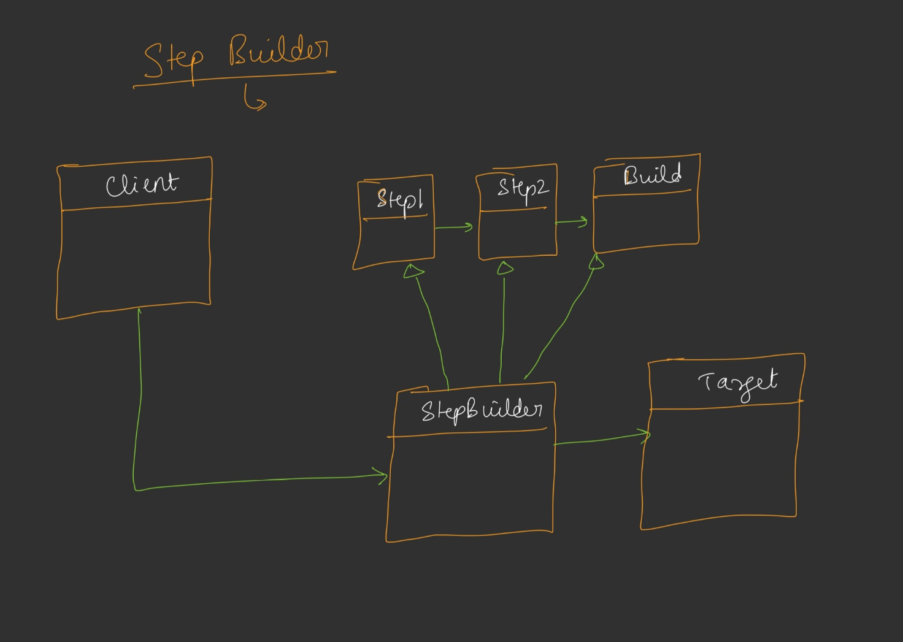

Builder Pattern Benefits Summary

Problems Solved
Problem | Solution
Constructor Overloading | Single builder class with fluent interface
Mutability | Object built once, immutable after build()
Inconsistent State | Validation in build() method
Scattered Validation | Centralized validation in build()

Advantages
- Readability: Fluent interface makes object creation self-documenting
- Immutability: Built objects are immutable
- Compile-time Safety: Step Builder enforces correct order
- Centralized Validation: All validation in one place
- Flexible Construction: Optional fields can be set in any order
- Open/Closed Principle: Easy to add new fields without breaking existing code
- Single Responsibility: Builder handles construction, Target handles behavior

When to Use Builder Pattern
- Object has many parameters (especially optional ones)
- Object construction is complex
- Object should be immutable
- Need to enforce construction order (Step Builder)
- Want to separate construction from representation

Standard Definition
"The Builder pattern separates the construction of a complex object from its representation so that the same construction process can create different representations."

Interview Tips
- Mention that Builder is the most commonly used pattern for object creation
- Explain the four problems: Constructor Overloading, Mutability, Inconsistent State, Scattered Validation
- Know the difference between classic Builder and Step Builder
- Understand why Step Builder uses multiple inheritance
- Be able to explain method chaining and intermediate vs terminating methods
- Discuss when to use Builder vs other creational patterns

Summary
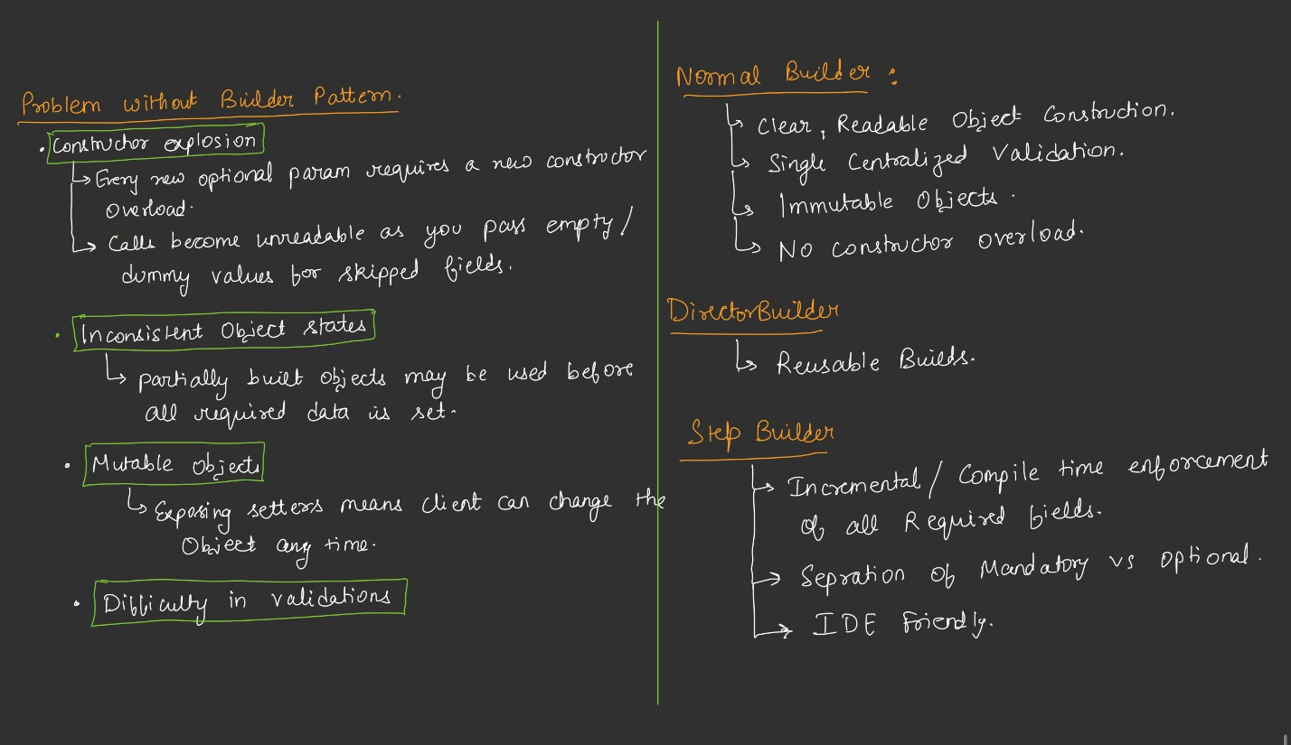

Code Repository Reference
The complete implementation of all three Builder variants (Classic, Director, Step) is available on GitHub. Practice implementing each variant to fully understand the differences and use cases.

